STANDARD SPECIFICATIONS FOR SPUNSTRAND® INC. UNDERSLAB AIR DUCT

Part 2 - Products

2.01 GENERAL

A. Underground ductwork, including fittings, shall be constructed of fiberglass reinforced plastic
manufactured by Spunstrand® Inc., 620 North Post Street, Post Falls, ID 83854.
208.777.7444 ph, 208.777.7445 fax. All duct and fittings shall be designed and constructed
to meet the applicable requirements of Uniform Mechanical Code, Chapter 6 and be listed
with ICC-ES for direct burial application. All ductwork and fittings shall include labels
certifying the actual code listings and report number, and shall be installed in strict accordance
with the manufacturer’s instructions.

2.02 MATERIALS

A. Resin - The resin used shall be high grade polyester, tested to meet the requirements of
Uniform Mechanical Code, Chapter 6 and suitable for corrosion against all normal soil and
moisture conditions. Resin systems with fillers exceeding 5% shall not be approved.
- Plastic (HDPE/PVC) ductwork and / or PVC coated galvanized steel ductwork shall NOT be acceptable.
B. Inner Lining - All duct and fittings shall have a UL listed Class 1 inner liner for both flame
spread and smoke developed ratings.
C. Structural Layer - The structural layer shall be filament wound of resin and glass to meet the
specified working pressures and depth of burial requirements.

2.03 INSULATION

- Underground ductwork shall be factory pre-insulated including all fittings. The duct shall be ICC-ES listed and installed in strict accordance with the manufacturer’s instructions. The insulation value of the duct shall be R-4, R-6, R-8, R-10 or R-12 as selected. Insulation values shall be tested per ASTM C-518 in an independent lab with a minimum of five years experience performing testing to this standard.
- R-values must be tested and approved in accordance with ASTM C518. ANY other test methods will not be acceptable and will be rejected during submittal review.
- TDE “equivalence” testing is NOT to be accepted.
- For product information please contact your local Spunstrand Rep:

___________________________
___________________________
___________________________
___________________________

2.04 ACCESSORIES

A. Fittings - Fittings shall be fabricated from straight duct and have the same working pressure
and shall also be corrosion and moisture resistant. Reducers shall be filament wound as
specified for the duct.
B. Joints - Field joints are to be watertight by using an internal galvanized sheet metal sleeve
secured with sheet metal screws. The joints shall then be of the wet lay-up type in strict
accordance with the manufacturer’s instructions. This includes thoroughly cleaning and
sanding areas to be joined and using manufacturer supplied polyester resin and fiberglass
mat.
Field Wet Joint Installation Instructions can be obtained from Spunstrand’s full-line catalog, Commercial Duct, Section 1 for Underslab Air Duct, on page 12.
C. Register Boots - Register boots, if constructed of galvanized sheet metal with a flange
secured to the duct with sheet metal screws, must be encased in concrete covering well
around the joint.
Preferred Option: Underground supply and / or return air plenums shall be made of the
same material as the duct. They shall be of one-piece construction including the stub outs
for connecting to the ductwork.

2.05 SILENCERS

- Fiberglass Reinforced Plastic Silencers shall be manufactured by Spunstrand® Inc. and David P. Wilson, FiberSonic Model FS-00-00-00, or pre-approved equal. Silencer shall be tested for insertion loss, self-noise, and pressure drop in an independent NVLAP accredited laboratory in full accordance with ASTM E477. Testing shall be completed and data available for review, 72 hours prior to bid date. Test data for insertion losses to meet or exceed the acoustical data published in the specification tables.
- Silencers above ground to installed per manufacturer’s recommendations.
- Silencers installed below ground should either be accessible inside a watertight concrete vault, or fitted with a schedule 80 PVC drain at the lowest point for piping back to plenum. Water entering the duct by any means will find a low point in the silencer, and must have a provision for draining. See Fibersonic Silencer™.
- Construction Specification and details available in Spunstrand’s full-line catalog, Industrial Section.

INSTALLATION INSTRUCTIONS FOR SPUNSTRAND® INC.
UNDERSLAB AIR DUCT

Part 3 - INSTALLATION

3.01 GENERAL

A. Spunstrand® Inc. duct is a semi-rigid reinforced thermosetting resin product designed to
deflect approximately 5% under external load without structural damage. The performance
of the duct is affected by the amount of strain introduced into the duct wall from internal
pressure, external loads and the resulting deflection of the duct with respect to its wall
thickness.
B. It is important to recognize the need for care in handling the duct during the installation
process and to properly provide uniform support for the duct by carefully placing the backfill
material under and around the duct. Large diameter duct will usually require internal support during the backfilling process and until all external soil loads have stabilized.
When installed underground, the load of the soil above the duct tends to flatten the duct and
make it wider. As the duct tries to widen, the walls push into the soil at the sides developing
a resistance that helps support the vertical load. The higher the soil resistance the less
the duct will deflect. Proper installation techniques are necessary to prevent excessive
deflections and potential duct buckling.

3.02 TRENCH CONSTRUCTION

A. The surface at the bottom of the trench should be continuous, smooth, and free of rocks to avoid point loading on the duct. Where this cannot be accomplished the trench bottom should be over excavated to allow a minimum of 4 inches of bedding material under the duct.
B. Trench width should not be greater than necessary to provide adequate room for joining the duct in the trench and for compacting the backfill in the bedding zone and at the sides of the duct. The minimum distance between the duct and the trench is four (4) inches; maximum recommended trench width is twice the diameter of the duct.
- Dewatering should be provided when there is a risk of flooding the trench during installation. Dewatering shall continue from the time the duct is first placed in the trench, until backfill or encasement is completed. Damage can occur when the duct is floated during a water uplift event.

3.03 JOINING THE DUCT

A. Because of its relatively low weight per foot, Spunstrand® Inc. duct can be joined before lowering into the trench thus minimizing the number of in-trench joints required during installation. Field joints require an internal galvanized sheet metal sleeve furnished by installing contractor (See Physical Data chart on page 9). Field joints to be of the wet lay-up type in strict accordance with the manufacturer’s instructions. This includes thoroughly cleaning and sanding areas to be joined. (See Drawing No. 1. on the following page.)

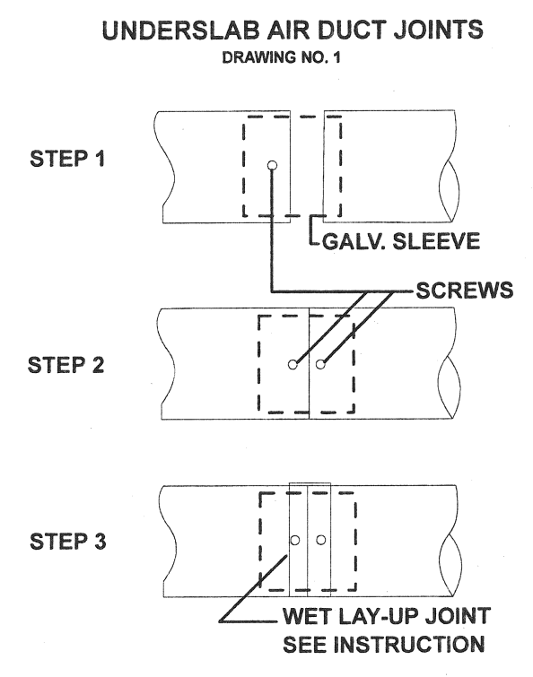

3.04 INSTALLATION

A. Installation shall be in strict accordance with the manufacturer’s instructions including but not limited to the following: duct to be installed in a trench with provision for good drainage and an allowance for a minimum of 4” pea gravel or dry silica sand to completely encase the duct. The top of the duct shall be at least 2 1/2” below the top of the concrete slab.

- Store and handle the duct so as to prevent damage. Carefully inspect each length before installation. If long sections are to be assembled alongside the trench then lowered into position, the duct run should be supported along its length to avoid strain and potential overstress or buckling of the duct or damage to the joints. Lay the duct in the trench so that it bears evenly on the bedding or bottom of the trench throughout its entire length. Arrows on the duct clearly mark the direction of airflow. A minimum thickness of 2 ½” of concrete is recommended where duct protrudes through the concrete. The maximum depth of burial for standard Spunstrand® Inc. underslab air duct allows for 5 feet of backfill cover. Deeper burial is possible; however, your Spunstrand® Inc. representative must be contacted for special recommendations that may be required. If the duct is not underslab it should be below the frost line. If the duct must pass directly under a load / weight bearing wall or under a road, reinforcement over the duct may be required. Again, please contact your Spunstrand® Inc. representative for specific requirements if your application meets these referenced, or any other custom considerations. (See Drawing No. 2 on the following page.)

